ICEngineSoft Test Report

Report Date : Sat, Apr 8, 2023 , Time : 9:41:13 PM
Organization : Organisation, Operator : Operator
Data File : 08-04 T30D70+H2 6LPM.xlsx, Last Modified Date: Sat, Apr 8, 2023,
Config. File : Kirloskar TV1 Engine.xls

Engine Details :

ICEngine set up under test is Kirloskar TV1 having power 5.20 kW @ 1500 rpm which is 1 Cylinder, Four stroke , Constant Speed, Water Cooled, Diesel Engine, with Cylinder Bore 87.50(mm), Stroke Length 110.00(mm), Connecting Rod length 234.00(mm), Compression Ratio 17.50, Swept volume 661.45 (cc)

Combustion Parameters :

Specific Gas Const (kJ/kgK) : 1.00, Air Density (kg/m^3) : 1.17, Adiabatic Index : 1.41, Polytrophic Index : 1.11, Number Of Cycles : 10, Cylinder Pressure Referance : 6, Smoothing 2, TDC Reference : 0

Performance Parameters :

Orifice Diameter (mm) : 20.00, Orifice Coeff. Of Discharge : 0.60, Dynamometer Arm Legnth (mm) : 185, Fuel Pipe dia (mm) : 12.40, Ambient Temp. (Deg C) : 27, Pulses Per revolution : 360, Fuel Type : Diesel, Fuel Density (Kg/m^3) : 835, Calorific Value Of Fuel (kj/kg) : 43070

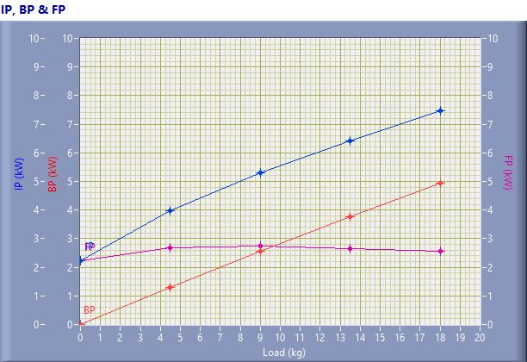

IP, BP & FP

Speed (rpm) | Load (kg) | IP (kW) | BP (kW) | FP (kW)
1567.00 | 0.02 | 2.23 | 0.01 | 2.23
1525.00 | 4.50 | 3.99 | 1.30 | 2.68
1500.00 | 9.02 | 5.30 | 2.57 | 2.73
1468.00 | 13.50 | 6.42 | 3.77 | 2.66
1438.00 | 18.02 | 7.48 | 4.93 | 2.56

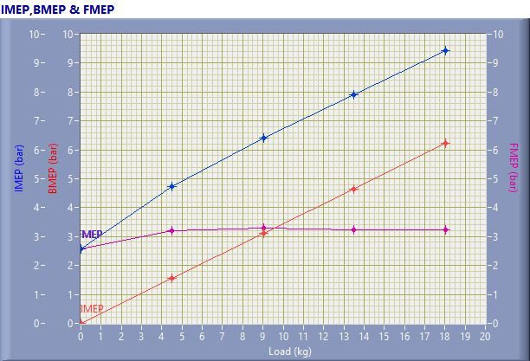

IMEP,BMEP & FMEP

Speed (rpm) | Load (kg) | IMEP (bar) | BMEP (bar) | FMEP (bar)
1567.00 | 0.02 | 2.58 | 0.01 | 2.58
1525.00 | 4.50 | 4.74 | 1.55 | 3.19
1500.00 | 9.02 | 6.41 | 3.11 | 3.30
1468.00 | 13.50 | 7.90 | 4.66 | 3.25
1438.00 | 18.02 | 9.44 | 6.21 | 3.23

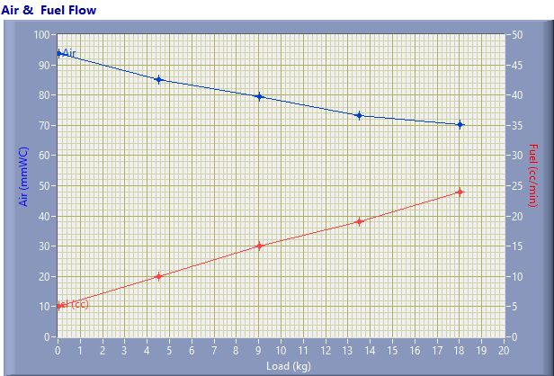

Air & Fuel Flow

Speed (rpm) | Load (kg) | Air (mmWC) | Fuel (cc/min)
1567.00 | 0.02 | 93.66 | 5.00
1525.00 | 4.50 | 85.19 | 10.00
1500.00 | 9.02 | 79.47 | 15.00
1468.00 | 13.50 | 73.11 | 19.00
1438.00 | 18.02 | 70.35 | 24.00

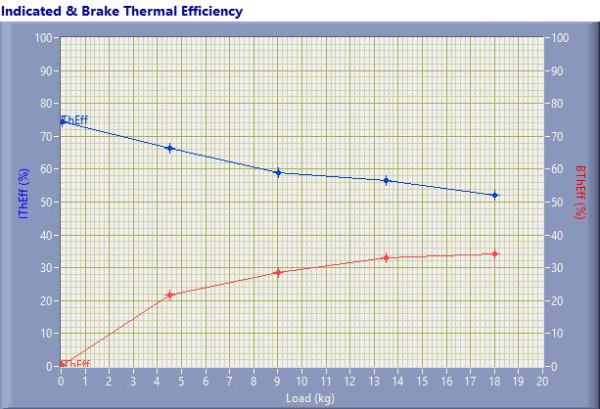

Indicated & Brake Thermal Efficiency

Speed (rpm) | Load (kg) | IThEff (%) | BThEff (%)
1567.00 | 0.02 | 74.48 | 0.21
1525.00 | 4.50 | 66.49 | 21.77
1500.00 | 9.02 | 58.93 | 28.60
1468.00 | 13.50 | 56.40 | 33.08
1438.00 | 18.02 | 52.01 | 34.24

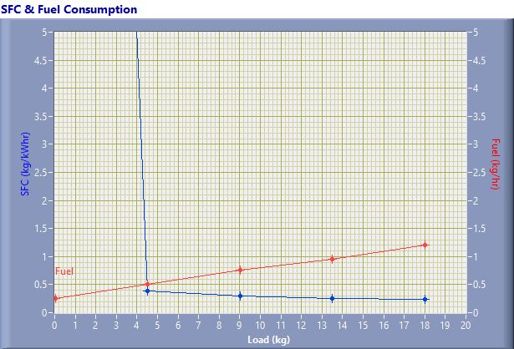

SFC & Fuel Consumption

Speed (rpm) | Load (kg) | SFC (kg/kWh) | Fuel (kg/h)
1567.00 | 0.02 | 40.05 | 0.25
1525.00 | 4.50 | 0.38 | 0.50
1500.00 | 9.02 | 0.29 | 0.75
1468.00 | 13.50 | 0.25 | 0.95
1438.00 | 18.02 | 0.24 | 1.20

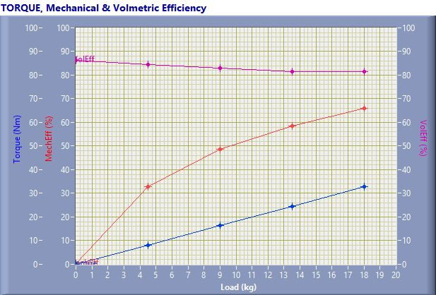

TORQUE, Mechanical & Volmertic Efficiency

Speed (rpm) | Load (Kg) | Torque (Nm) | Mech Eff. (%) | Vol Eff. (%)
1567.00 | 0.02 | 0.04 | 0.28 | 86.34
1525.00 | 4.50 | 8.17 | 32.74 | 84.61
1500.00 | 9.02 | 16.37 | 48.54 | 83.09
1468.00 | 13.50 | 24.50 | 58.64 | 81.43
1438.00 | 18.02 | 32.71 | 65.83 | 81.54

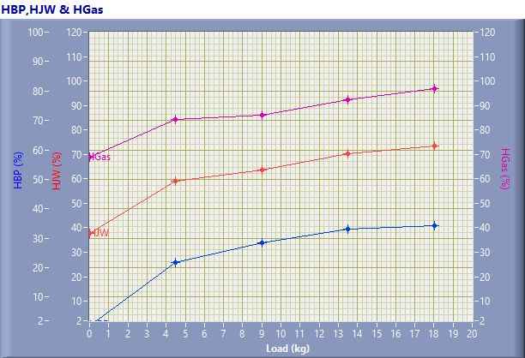

HBP,HJW & HGas

Speed (rpm) | Load (kg) | HBP (%) | HJW (%) | HGas (%) | HRad (%)
1567.00 | 0.02 | 0.21 | 37.39 | 31.30 | 31.11
1525.00 | 4.50 | 21.77 | 37.31 | 25.34 | 15.58
1500.00 | 9.02 | 28.60 | 35.14 | 22.24 | 14.02
1468.00 | 13.50 | 33.08 | 37.32 | 21.99 | 7.62
1438.00 | 18.02 | 34.24 | 39.36 | 23.20 | 3.20

Observation Data

Speed (rpm) | Load (kg) | Comp Ratio | T1 (deg C) | T2 (deg C) | T3 (deg C) | T4 (deg C) | T5 (deg C) | T6 (deg C)
1567 | 0.02 | 17.50 | 39.95 | 44.75 | 39.96 | 38.51 | 123.63 | 105.20
1525 | 4.50 | 17.50 | 40.02 | 49.60 | 40.02 | 40.27 | 189.65 | 151.63
1500 | 9.02 | 17.50 | 40.11 | 53.65 | 40.12 | 42.03 | 246.69 | 194.14
1468 | 13.50 | 17.50 | 40.14 | 58.35 | 40.15 | 44.14 | 311.62 | 242.64
1438 | 18.02 | 17.50 | 40.27 | 64.54 | 40.28 | 47.15 | 394.87 | 302.56

Observation Data

Air (mmWC) | Fuel (cc/min) | WaterFlow Engine (lph) | WaterFlow Cal (lph)
93.66 | 5.00 | 200 | 100
85.19 | 10.00 | 200 | 100
79.47 | 15.00 | 200 | 100
73.11 | 19.00 | 200 | 100
70.35 | 24.00 | 200 | 100

Result Data

Torque (Nm) | BP (kW) | FP (kW) | IP (kW) | BMEP (bar) | IMEP (bar) | BTHE (%) | ITHE (%) | Mech Eff. (%)
0.04 | 0.01 | 2.23 | 2.23 | 0.01 | 2.58 | 0.21 | 74.48 | 0.28
8.17 | 1.30 | 2.68 | 3.99 | 1.55 | 4.74 | 21.77 | 66.49 | 32.74
16.37 | 2.57 | 2.73 | 5.30 | 3.11 | 6.41 | 28.60 | 58.93 | 48.54
24.50 | 3.77 | 2.66 | 6.42 | 4.66 | 7.90 | 33.08 | 56.40 | 58.64
32.71 | 4.93 | 2.56 | 7.48 | 6.21 | 9.44 | 34.24 | 52.01 | 65.83

Result Data

Air Flow (kg/h) | Fuel Flow (kg/h) | SFC (kg/kWh) | Vol Eff. (%) | A/F Ratio | HBP (%) | HJW (%) | HGas (%) | HRad (%)
31.52 | 0.25 | 40.05 | 86.34 | 125.81 | 0.21 | 37.39 | 31.30 | 31.11
30.06 | 0.50 | 0.38 | 84.61 | 60.00 | 21.77 | 37.31 | 25.34 | 15.58
29.03 | 0.75 | 0.29 | 83.09 | 38.63 | 28.60 | 35.14 | 22.24 | 14.02
27.85 | 0.95 | 0.25 | 81.43 | 29.25 | 33.08 | 37.32 | 21.99 | 7.62
27.32 | 1.20 | 0.24 | 81.54 | 22.72 | 34.24 | 39.36 | 23.20 | 3.20

